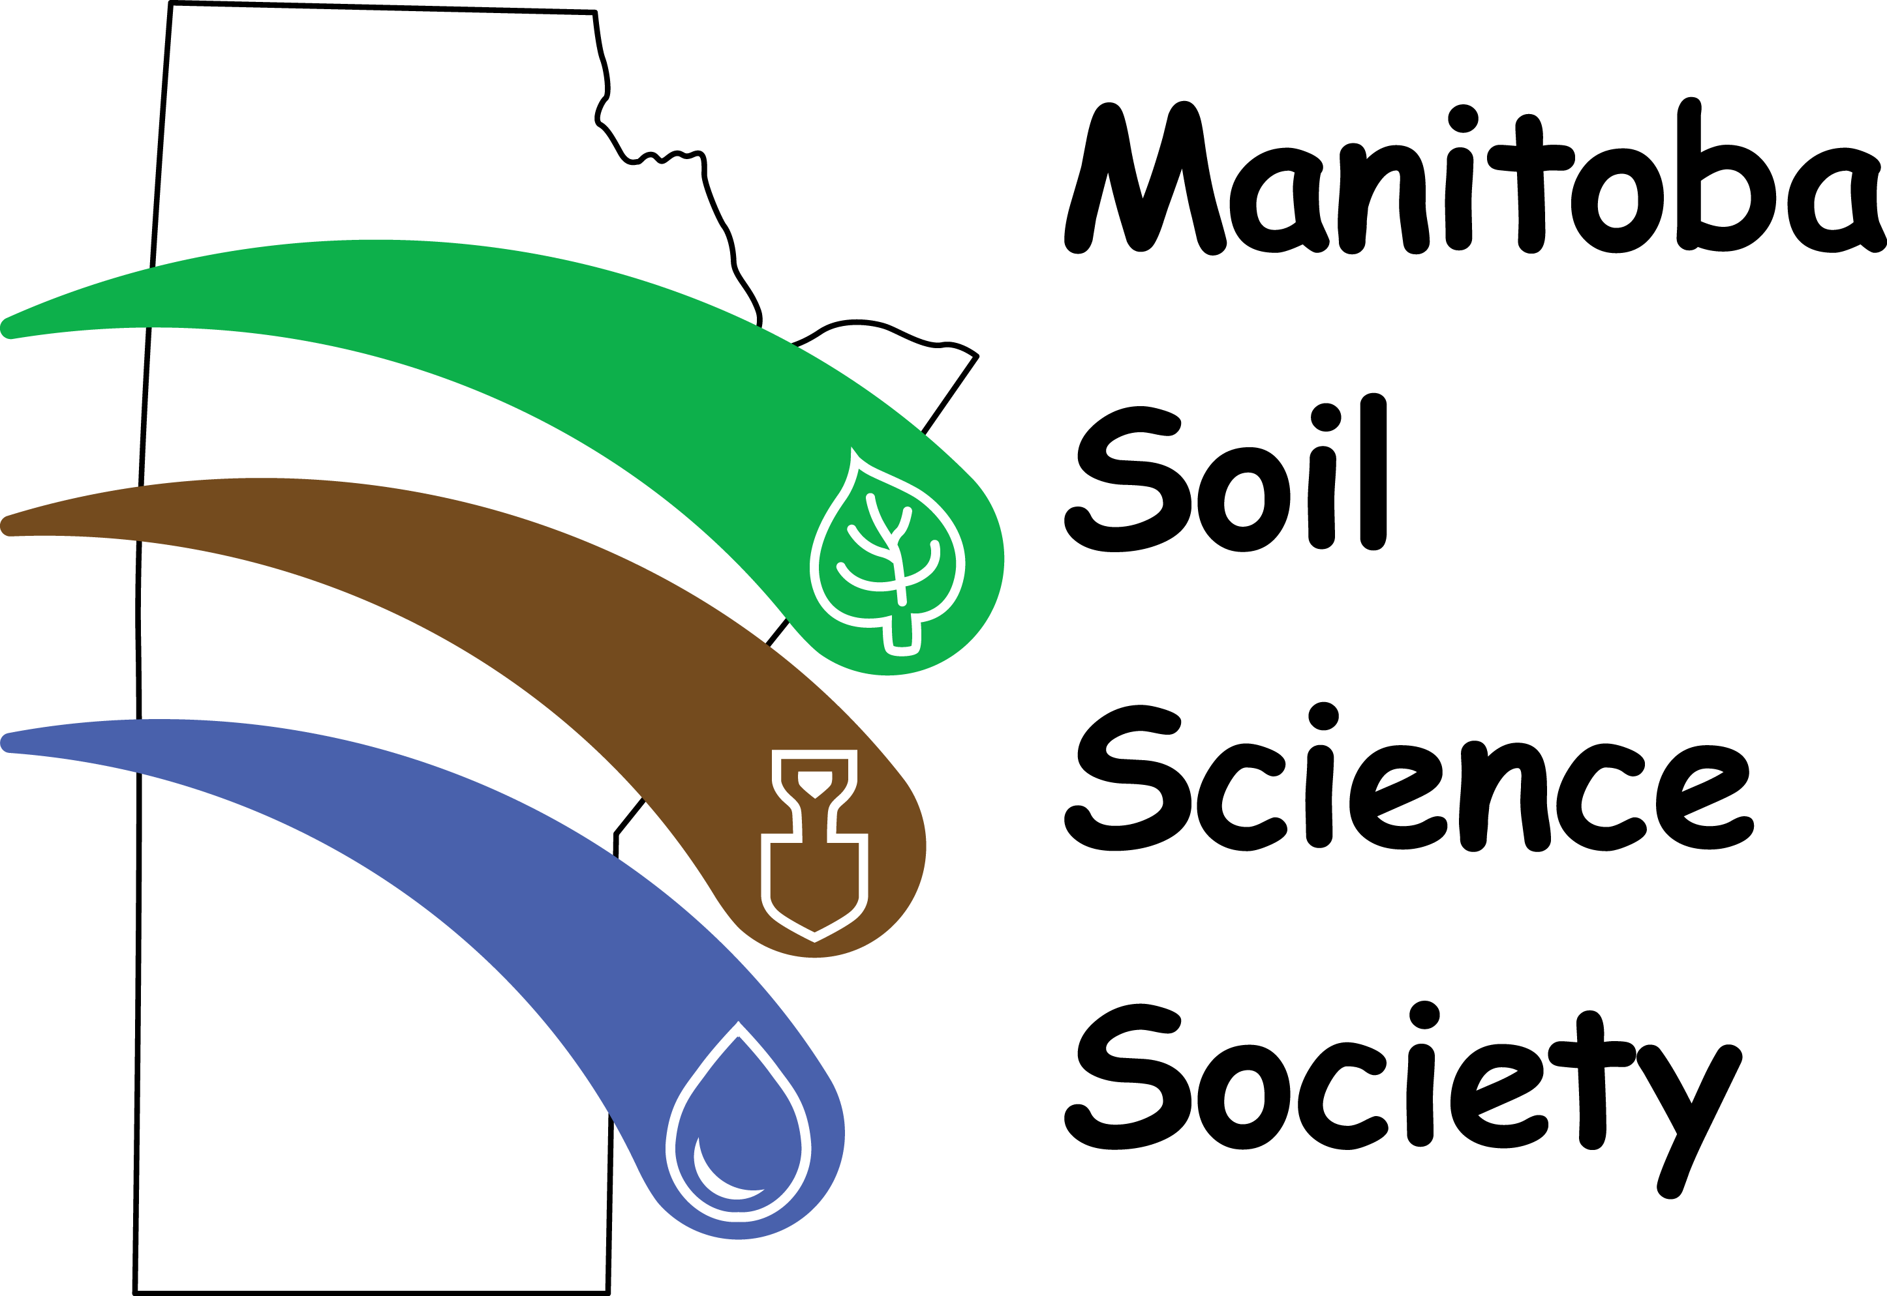
Call for Papers

64th MSSS Annual General Meeting

February 4-5, 2021 | Virtual Meeting

The Manitoba Soil Science Society (MSSS) holds an Annual General Meeting to provide industry professionals and academics a place to share their research findings and network. This year’s plenary session theme is “Soil Webs; Keeping connected by collaborating between disciplines”. Please visit the MSSS website (mbsoils.ca) for updates on the event program.

Both oral and poster presentation submissions are welcome. Poster presentations this year will include one-minute pre-recorded poster pitches. Oral Presentations will involve a 10-minute pre-recorded presentation with a live 2 minute Q&A. Please submit contact information and abstracts to MSSS by January 8, 2021. Abstracts are to include the Title, Authors, Author Affiliations, and Abstract Text of less than 300 words. A sample abstract with the required formatting is included on the next page.

Due to time constraints with the virtual meeting format this year, we will only be accepting a certain number of oral and poster presentations. Please send your abstract in early! Pre-recordings must be in by January 31, 2021.

Graduate Students: Graduate student presentations are judged with awards for best oral and poster presentations. You must put an asterisk after your name on the submitted abstract to be considered for an award.

Contact & Presentation Information

Name
Company/Affiliation
Mailing Address
Phone
Email
Graduate Student |  | ☐ Yes | ☐ No
Presentation Type | ☐ Oral Presentation |  | ☐ Poster Presentation
Presentation Title
Please note that we will be using email as the primary means of contact. Pre-recorded oral and poster presentations must be submitted by January 31st, 2021.

Please send the above information and abstract as a .doc or .docx file to: msss@umanitoba.ca.

SAMPLE ABSTRACT

Nitrogen Uptake by Barley Grown in Chernozemic Soils Amended with Anaerobically Digested Manure
Waraidzo Chiyoka^{1, 2}*, Francis Zvomuya¹ and Xiying Hao²
¹Department of Soil Science, University of Manitoba, Winnipeg, Manitoba, Canada.
²Agriculture and Agri-Food Canada, Lethbridge Research Centre, 5403 1st Ave. S., Lethbridge, Alberta, Canada
Anaerobically digested manure (ADM) is a nutrient rich substrate co-generated during biogas production from anaerobic digestion of livestock manure. Currently, the separated solid fraction of ADM (SS) is commonly applied to cropland at rates equivalent to those for raw manure. We hypothesize that biophysicochemical changes occurring during anaerobic digestion may result in a digested product with a different N supplying power. We tested this using five, 6-wk cycles of forage barley (Hordeum Vulgare L.) grown in a Dark Brown and a Black Chernozem amended with raw beef cattle (Bos taurus) feedlot manure, SS, pelletized SS (PSS) and synthetic fertilizer (urea + monoammonium phosphate, UMP). Amendments were applied at rates calculated to supply 400 and 800 mg total N kg⁻¹ soil, with a control included for comparison. At each harvest, plant roots and shoots were harvested separately and analyzed for total N. Amendment-derived N content of total biomass was highest for UMP and manure, and lowest for PSS at both rates. The difference between manure and SS was higher at the higher amendment rate, while both PSS rates depressed N uptake relative to non-amended soils. Amendment-derived N also increased with increasing rate for all amendments except PSS. We conclude that anaerobic digestion does not alter N availability and uptake from beef cattle manure while pelletization of the solid fraction of digested manure can cause N immobilization and depress plant N uptake.

